PCA Dimension Reduction Example

1. Original Dataset
Sample | Feature 1 (X1) | Feature 2 (X2) | Feature 3 (X3)
A | 2.5 | 2.4 | 0.5
B | 0.5 | 0.7 | 2.2
C | 2.2 | 2.9 | 3.1
D | 1.9 | 2.2 | 1.4
E | 3.1 | 3.0 | 0.9
F | 2.3 | 2.7 | 2.3
G | 2.0 | 1.6 | 1.0
H | 1.0 | 1.1 | 1.3
I | 1.5 | 1.6 | 2.0
J | 1.1 | 0.9 | 2.5

2. Standardize the Data
First, we standardize each feature so that each has a mean of 0 and a standard deviation of 1.
Standardized Dataset: 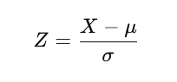
Sample | Standardized Feature 1 (X1) | Standardized Feature 2 (X2) | Standardized Feature 3 (X3)
A | 0.85 | 0.84 | -1.26
B | -1.76 | -1.7 | 0.27
C | 0.32 | 1.28 | 1.74
D | -0.11 | 0.29 | -0.42
E | 1.59 | 1.39 | -1.02
F | 0.11 | 1.01 | 0.58
G | -0.43 | -0.86 | -0.98
H | -1.19 | -1.39 | -0.76
I | -0.65 | -0.86 | 0.08
J | -1.03 | -1.75 | 0.77

3. Compute the Covariance Matrix
Next, we compute the covariance matrix of the standardized data. The covariance matrix is calculated as follows:
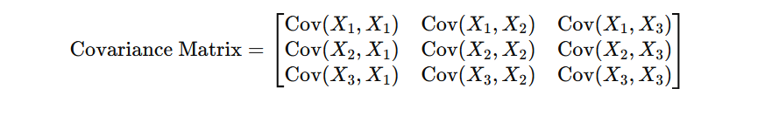
Cov(X, Y) = (1 / (n-1)) * Σ(Xi - X̄)(Yi - Ȳ)
where X and Y are features, Xi and Yi are individual data points, X̄ and Ȳ are the means of the features, and n is the number of samples.
For our standardized dataset, the means are zero, so the covariance calculation simplifies to:
Cov(X, Y) = (1 / (n-1)) * Σ(Xi Yi)
The covariance matrix for our standardized dataset is:
Covariance Matrix:
[ [1.0, 0.86, 0.53],
[0.86, 1.0, 0.32],
[0.53, 0.32, 1.0] ]

4. Compute the Eigenvalues and Eigenvectors
To find the eigenvalues and eigenvectors, we solve the characteristic equation of the covariance matrix:
det(C - λI) = 0
where C is the covariance matrix, λ is an eigenvalue, and I is the identity matrix.
For our covariance matrix:
det| 1.0 - λ 0.86 0.53 |
| 0.86 1.0 - λ 0.32 |
| 0.53 0.32 1.0 - λ| = 0
Solving this cubic equation gives us the eigenvalues:
λ1 = 1.87, λ2 = 0.83, λ3 = 0.30
The corresponding eigenvectors are found by solving:
(C - λI)v = 0
For our eigenvalues, the eigenvectors are:
v1 = [0.68, 0.67, 0.29]
v2 = [-0.67, 0.74, -0.05]
v3 = [-0.28, -0.06, 0.96]

5. Select Principal Components
We select the top 2 eigenvectors (principal components) based on the eigenvalues.
Principal Components:
v1 = [0.68, 0.67, 0.29]
v2 = [-0.67, 0.74, -0.05]

6. Transform the Data
We project the standardized data onto the selected principal components. This is done by multiplying the standardized data matrix by the matrix of the selected eigenvectors.
Transformed Data:
Sample | Principal Component 1 | Principal Component 2
A | 1.44 | 0.29
B | -1.8 | -0.39
C | 1.78 | -0.29
D | 0.28 | 0.79
E | 2.01 | -0.53
F | 1.16 | 0.2
G | -0.84 | 0.5
H | -1.65 | -0.2
I | -0.9 | 0.34
J | -1.67 | -0.51

